Oriane-Menguy 6ème C

My school trip to l'Abervrac'h

Thursday 12th June

I had breakfast at 8:00 o'clock .
I had milk and apple juice and cereals .

In the morning ,at 9:00 o'clock ,I went sailing on a catamaran.It was fun ! 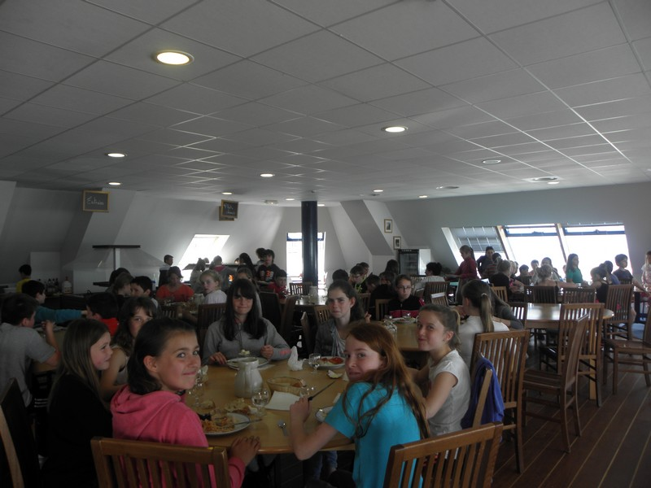 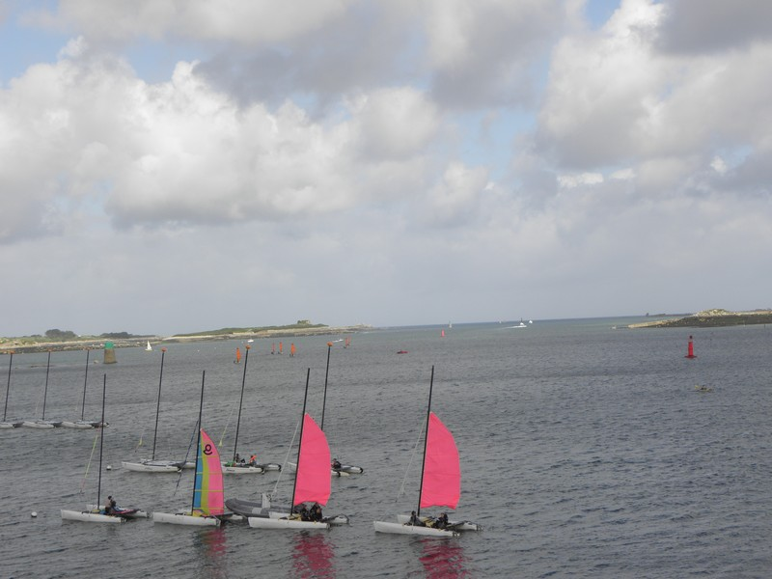

At 12:45,for lunch,I had mussels and chips Yummy !!!!!!!!!!
For dessert,I had a banana

In the afternoon,at 14:00,I studied cartography
For dinner,I had couscous,For dessert bananas.
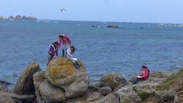 THE END !

